**QF 604 – Econometrics of Financial Markets**

**The Dow Jones Utility Average & Smart Beta Alternatives**

**Team Members:** Jin Weiguo, Kim Chan-Jung, Johnny Quek, Wang Boyu, Woon Tian Yong

**Section 1: Introduction**

The Dow Jones Utility Average (DJUA), a member of the Dow Jones Global Indexes, was created in 1929 when utility stocks were removed from the Dow Jones Industrial Average. The DJUA tracks the overall performance of a small group of 15 utility stocks traded in the U.S. by using a price-weighted average method. Constituent companies are primarily producers of utility resources such as electricity and natural gas. In addition, these utility companies typically pay sizable dividends and provide a steady stream of dividend income relative to companies from other sectors as they face less uncertainty and minimal future volatility due to nature of their industry. This therefore results in utility sector stocks to be typically seen as a favourite for retirees and other income-seeking investors. In hope of constructing an index that outperforms the price-weighted DJUA, our team decided to construct smart-beta indices which weigh constituent stocks by fundamentals instead of price. We then analysed and appraised the findings of our endeavour.

**Section 2: Data Sources & Preparation**

Our data sample includes stock and relevant fundamentals data on all stocks which have ever been members of the Dow Jones Utility Average index for the period between 1963 and 2018 (the sample period). We obtained the bulk of our data from Wharton Research Data Services (WRDS), from which the Center for Research in Security Prices (CRSP), Compustat - Capital IQ and CRSP/Compustat Merged Database (CCM) databases were utilised. We also tapped on the Bloomberg database for membership data on the Dow Jones Utility Average, though the information provided was incomplete and was supplemented by information from [this article by Global Financial Data](https://www.globalfinancialdata.com/GFD/Article/a-brief-history-of-the-dow-jones-utility-average).

**Center for Research in Security Prices (CRSP)**

The Center for Research in Security Prices (CRSP) provided us with relevant data on the monthly closing price, adjusted returns and outstanding number of stocks. We used PERMCOs and PERMNOs as unique entity and issue identifiers when navigating the CRSP database.

**Compustat - Capital IQ**

Compustat provided us with the relevant fundamentals data (e.g. Net Income, Operating Cash Flow etc) on the relevant constituent stocks of the Dow Jones Utility Average. We used GVKEY as unique entity-level identifiers when navigating the Compustat database.

**CRSP/Compustat Merged Database (CCM)**

We used the CCM Database to obtain the links between the unique PERMCO and GVKEY identifiers for the CRSP and Compustat databases respectively. This allowed us to be able to link stock price and market capitalisation data to other corresponding fundamentals (e.g. computed ROCE, ROA numbers) data at the entity level. With that said, not all required data was found to be available for our sample period.

**Computation of Fundamentals**

Using data obtained from both CRSP and Compustat, the following 10 selected fundamentals were then computed for each eligible company for each year:

|  |  |  |  |  |
| --- | --- | --- | --- | --- |
| **Description** | **Equation** | **Price Return Index** | **Total Return Index** | **Comments** |
| Market Capitalisation | Share Price x No. of Shares Outstanding | Yes | Yes |  |
| Return on Assets | Net Income/Total Assets | Yes | Yes |  |
| Return on Capital Employed | EBIT/Capital Employed | Yes | Yes | Capital Employed = Total Assets - Current Liabilities |
| Return on Invested Capital | NOPAT/Invested Capital | Yes | Yes | NOPAT = EBIT x (1-Tax Rate) |
| Gross Margin | Gross Profit/Revenue | Yes | Yes |  |
| Profit Margin | Net Income/Revenue | Yes | Yes |  |
| EBITDA Margin | EBITDA/Revenue | Yes | Yes |  |
| Operating Cash Flow Margin | Operating Cash Flow/Revenue |  | Yes |  |
| Current Ratio | Current Assets/Current Liabilities | Yes | Yes |  |
| Long Term Debt to Total Equity | Long Term Debt/Total Equity | Yes | Yes |  |

**Section 3: Smart Beta Index Construction, Methodology & Initial Findings**

We then proceeded to construct smart beta indices based on the 10 fundamentals we have selected. Our weighting method is as follows:

$$w_{i,t}=\frac{f_{i,t-1}}{\sum_{i=1}^{N≤15}{f_{i,t-1}}}, \sum_{i=1}^{N≤15}{w_{i,t}}=1$$

where $w_{i,t}$ is the weight assigned for stock $i$ for trading year $t$, based on its fundamentals data from fiscal year $t-1$, where the sum of the weights of the individual stocks for any year is 1. For every year, only stocks of companies which were officially members of the benchmark index (the Dow Jones Utility Average) were included in this weighting process. In the case of the problem of missing data encountered for certain eligible companies in certain years, said companies will be excluded from the Index for that year ($w_{i,t}=0$). For that reason, our constructed indices may have less than 15 constituent stocks for some years, but never more than 15 constituent stocks for any year (as with the benchmark index).

Our constructed price and total return smart beta indices were first constructed on June 1963 and June 1988 respectively, with rebalancing taking place every year at the end of June. The weighting approach using fundamentals data from fiscal year $t-1$ for weights for trading year $t$, coupled with our approach of performing annual rebalancing only in end-June allows for the real-world replication of our smart beta indices based on known values at the time, as full fiscal year fundamentals data are usually only released at the end of Q1 of every calendar year. Further, we only started our smart beta total return indices from June 1988 owing to a lack of prior price data on the relevant benchmark index (the Dow Jones Utility Average Total Return) and on Operating Cash Flow Margin fundamentals data. As can be inferred, owing to a lack of data, price return smart beta indices based on Operating Cash Flow Margin were not constructed.

Given how some of our chosen fundamentals (e.g. ROA, ROCE, ROIC etc) can take on negative values, we allowed our indices to be fully unconstrained. This means that long or short positions on eligible stocks were permitted with no set limits. We also established an “absorbing state” for the prices of the smart beta indices to be at 0 (indicating a total loss of initial capital), with any of our indices reaching or exceeding that floor deemed to be failed ones and as such excluded from further analysis.

**Initial Findings**

The superior smart beta index become clear as day after the computed smart beta index prices were plotted over time. For both price return and total return smart beta portfolios, the portfolios with ROIC-based weightings achieved far superior returns over our other constructed indices.

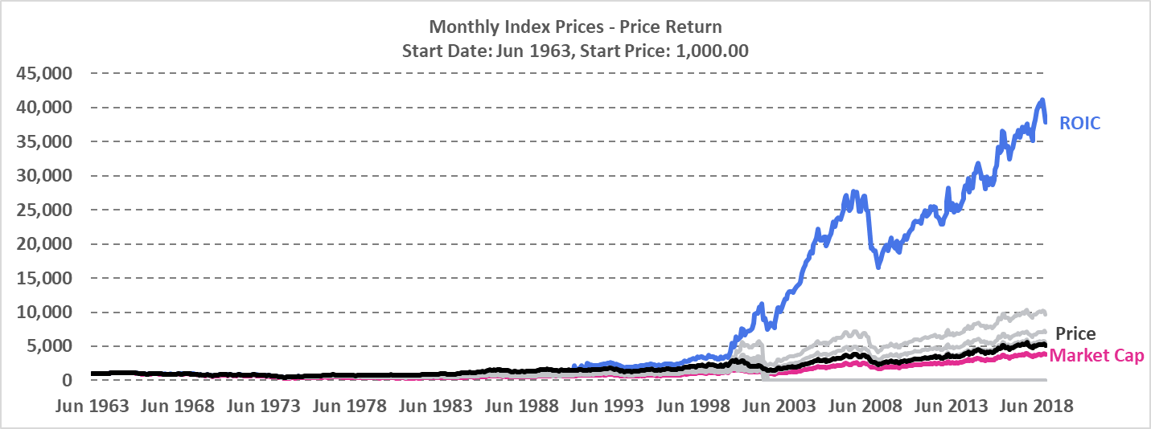

To put things into perspective, the value of $1 invested in our constructed ROIC-based total return smart beta portfolio at Jun 1988 would be worth $197.10 at the end of 2018 (excluding transaction costs), while an identical $1 invested in the benchmark total return index over the same time period would be worth “only” $15.77.

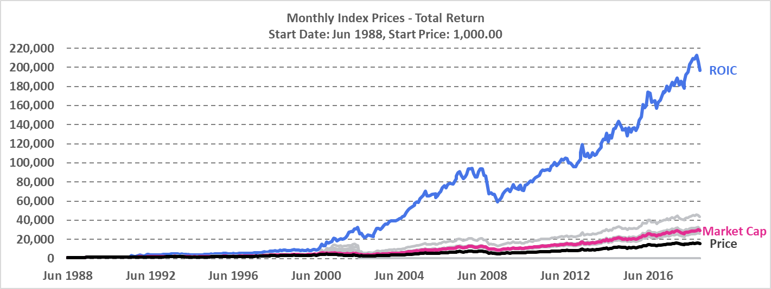

For our constructed price return indices, coming in as faraway second and third place were the ROCE and Current Ratio-based smart beta indices. Amongst the portfolios which survived the sample period, indices weighed based on price and market capitalisation performed the worst.

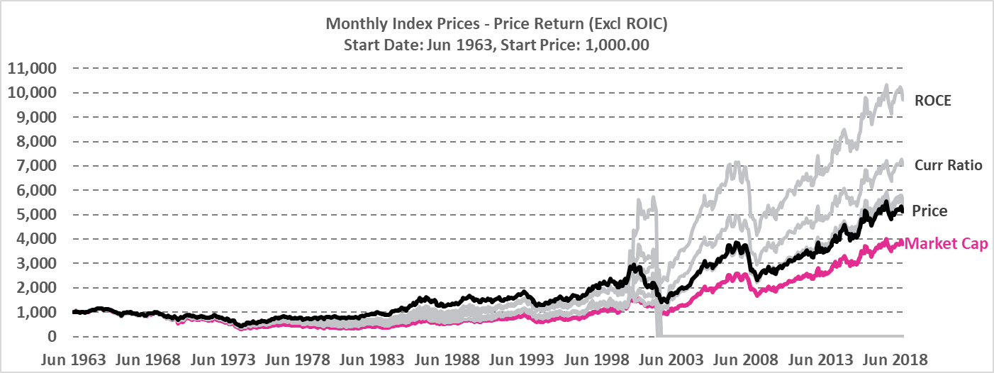

As with the case of the constructed price return indices, the second-best performing total return smart beta portfolio was the one weighted based on ROCE, with the Operating Cash Flow Margin-based index coming in third. The price-weighted index was once again amongst the worst performing but surviving ones.

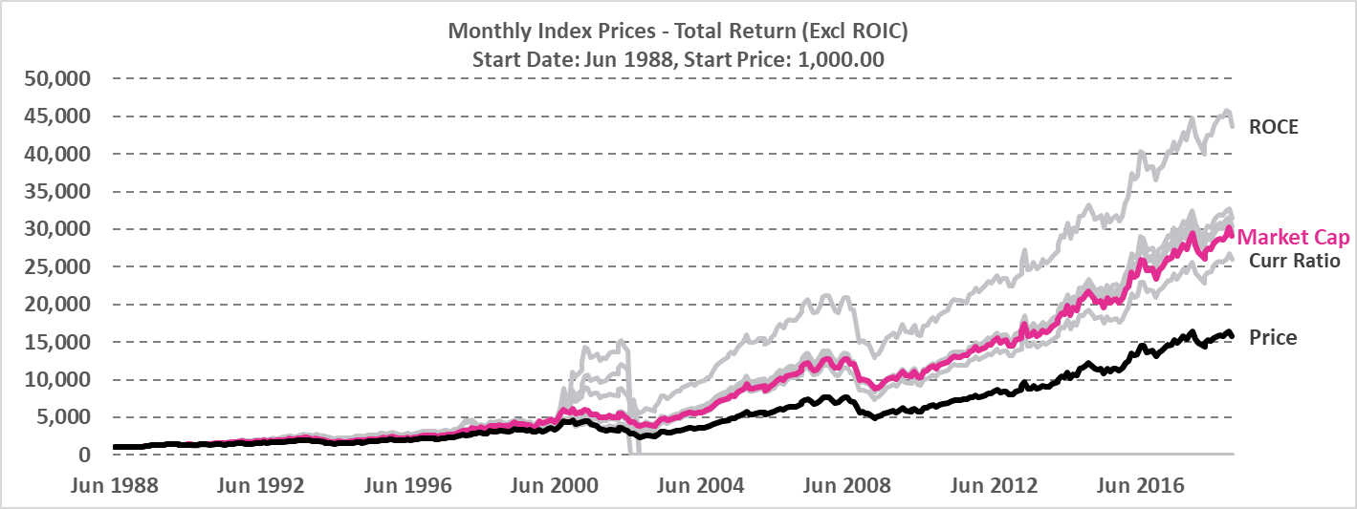

We also observed a few constructed portfolios which have failed over our sample period, namely the ones with weight allocations based on ROA, Profit Margin and LTDE Ratio.

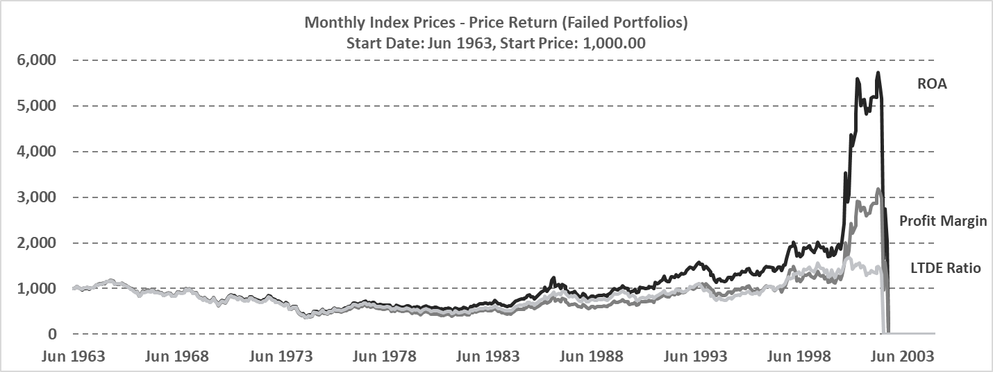

All of the failure cases were the result of a few extensive (and sometimes successive) losses incurred from prescribed unprofitable and extremely large short positions taken on the same few constituent stocks, the result of one of the drawbacks that come with allowing fully unconstrained portfolios. The failures were also observed to all have occurred in mid-to-late 2002.

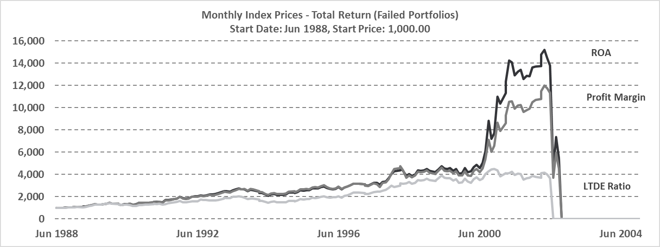

Failed constructed portfolios were excluded from further analysis.

**Section 4: Index Performance Appraisal**

**Section 4.1 Geometric Monthly Return**

Table 1 and Table 2 show the performance of the original Dow Jones Utility Index and alternative fundamental indices for price return from July 1961 to December 2018 and total return from July 1988 to December 2018, respectively.

Of particular note from the tables is that most of the fundamental indices in price return fail to generate excessive returns over Dow Jones Utility Average (DJUA) that are statistically indifferent from zero, whereas most total return fundamental indices manifest statistically significant outperformance over DJUA with an average t-statistic of 2.93. This seems to be due to the fact that the utility index consists mainly of stable stocks that earn profit from dividends rather than stock price rises; the average geometric return of total return indices is nearly three times higher than that of price return indices. For the same reason, most of price return indices underperformed risk-free rate during the observed period.

In the suggested ten fundamental metrics, Market Capitalisation is related to the size of firms and remaining metrics are about profitability ratio or balance sheet ratio. It is interesting that all the metrics except for Current Ratio of total return outperformed Market Capitalisation in terms of geometric return. It implies that perhaps profitability ratios are superior to firm size-related indicators, if the goal is to attain possible maximum return.

It is noticeable that ROIC is the only metric that produces statistically significant outperformance over the original indices in both price return and total return, having t-statistics of 1.80 and 2.17 for each return. Although ROIC does not render the largest Sharpe Ratio and Information Ratio for total return owing to its high volatility, ROIC has unrivaled profitability among the various indicators. The monthly geometric return of ROIC is as high as about 1.5 times of average geometric return for both price and total returns.

**Table 1 Monthly Performances of Fundamentally Weighted Price Return Indices, Jan 1964 - Dec 2018**

|  |  |  |  |  |  |  |  |  |  |
| --- | --- | --- | --- | --- | --- | --- | --- | --- | --- |
| Index | Ending Value of 1$ | Geometric  Return | Volatility | VS RF rate  (3M US Treasury) | | | VS Original Index | | |
| **Excess Return** | **Sharpe Ratio** | **t-Stats\*** | **Excess Return** | **Information Ratio** | **t-Stats\*** |
| DJUAPR | $ 5.14 | 0.25% | 4.14% | -0.14% | -0.03 | -0.31 | - | - | - |
| ROIC  (Return on Invested Capital) | $ 37.61 | 0.55% | 7.73% | 0.16% | 0.02 | 1.32 | 0.31% | 0.05 | 1.80 |
| ROCE  (Return on Capital Employed) | $ 9.67 | 0.34% | 4.79% | -0.04% | -0.01 | 0.39 | 0.10% | 0.05 | 1.48 |
| Gross Margin | $ 5.52 | 0.26% | 4.53% | -0.13% | -0.03 | -0.13 | 0.01% | 0.01 | 0.40 |
| EBITDA Margin | $ 5.34 | 0.25% | 4.51% | -0.13% | -0.03 | -0.16 | 0.01% | 0.00 | 0.32 |
| Current Ratio | $ 6.99 | 0.30% | 4.49% | -0.09% | -0.02 | 0.07 | 0.05% | 0.03 | 0.90 |
| Market Capitalisation | $ 3.77 | 0.20% | 4.53% | -0.18% | -0.04 | -0.46 | -0.05% | -0.03 | -0.41 |
| Average | $ 10.58 | 0.31% | 4.96% | -0.08% | -0.02 | 0.10 | 0.07% | 0.02 | 0.75 |

* One-tail critical t-statistics is 1.65

**Table 2 Monthly Performances of Fundamentally Weighted Total Return Indices, Jan 1989 - Dec 2018**

|  |  |  |  |  |  |  |  |  |  |
| --- | --- | --- | --- | --- | --- | --- | --- | --- | --- |
| Index | Ending Value of 1$ | Geometric  Return | Volatility | VS RF rate  (3M US Treasury) | | | VS Original Index | | |
| **Excess Return** | **Sharpe Ratio** | **t-Stats\*** | **Excess Return** | **Information Ratio** | **t-Stats\*** |
| DJUATR | $ 6.16 | 0.75% | 4.17% | 0.51% | 0.12 | 2.70 | - | - | - |
| ROIC  (Return on Invested Capital) | $ 181.77 | 1.46% | 9.32% | 1.21% | 0.13 | 3.11 | 1.07% | 0.13 | 2.17 |
| ROCE  (Return on Capital Employed) | $ 40.60 | 1.03% | 4.78% | 0.79% | 0.16 | 3.58 | 0.65% | 0.27 | 3.20 |
| Gross Margin | $ 28.79 | 0.94% | 4.45% | 0.69% | 0.16 | 3.38 | 0.55% | 0.27 | 3.11 |
| EBITDA Margin | $ 28.19 | 0.93% | 4.42% | 0.69% | 0.16 | 3.38 | 0.54% | 0.27 | 3.10 |
| Operating Cash Flow Margin | $ 29.46 | 0.94% | 4.21% | 0.70% | 0.17 | 3.55 | 0.55% | 0.29 | 3.38 |
| Current Ratio | $ 24.56 | 0.89% | 4.44% | 0.65% | 0.15 | 3.20 | 0.51% | 0.26 | 2.34 |
| Market Capitalisation | $ 26.76 | 0.92% | 4.19% | 0.67% | 0.16 | 3.44 | 0.52% | 0.29 | 3.23 |
| Average | $ 45.79 | 0.98% | 5.00% | 0.74% | 0.15 | 3.29 | 0.63% | 0.26 | 2.93 |

* One-tail critical t-statistics is 1.65

As is shown in Table 3 and Table 4, Market Capitalisation, the only size metric has the smallest absolute value in skewness, and the third smallest absolute value in kurtosis for both price and total return. This means that return distribution of Market Capitalisation index is almost symmetrical and has thin tail, which is also in line with the low volatility of Market Capitalisation index. Most of profitability ratio and balance sheet ratio indices are more exposed to big downside risk than Market Capitalisation or the original index is.

ROIC has extremely high absolute values for kurtosis. The fact that ROIC has fat tails in their distributions can also be seen in its relatively large maximum and minimum return. Nevertheless, having fat tail does not necessarily make ROIC bad. ROIC has large positive value – 8.30 and 8.43 respectively for price return and total return - as its skewness, which means we are more likely to enjoy upside potential from these indices than to suffer from downside risk. As a matter of fact, maximum return is nearly four times greater than minimum monthly return in absolute term for 1-month, 3-month, and 12-month returns. This also accords with that ROIC is the most profitable index in Table 1 and 2.

**Table 3 Distribution of Fundamentally Weighted Price Return Indices, Jan 1964 - Dec 2018**

|  |  |  |  |  |  |  |  |  |
| --- | --- | --- | --- | --- | --- | --- | --- | --- |
| Index | Skewness | Kurtosis | Maximum Monthly Return | Minimum Monthly Return | Maximum 3-Month Return | Minimum  3-Month Return | Maximum 12-Month Return | Minimum  12-Month Return |
| DJUAPR | -0.23 | 0.82 | 13.41% | -16.02% | 27.68% | -24.55% | 46.70% | -41.68% |
| ROIC | 8.30 | 138.22 | 134.33% | -30.60% | 125.15% | -27.62% | 161.42% | -43.59% |
| ROCE | 0.26 | 2.48 | 27.47% | -17.66% | 55.88% | -28.14% | 100.79% | -41.76% |
| Gross Margin | -0.20 | 1.35 | 16.88% | -21.34% | 40.09% | -30.76% | 62.44% | -44.46% |
| EBITDA Margin | -0.18 | 1.19 | 16.88% | -20.12% | 37.60% | -28.96% | 56.73% | -44.46% |
| Current Ratio | -0.21 | 1.67 | 19.25% | -21.33% | 39.49% | -34.02% | 67.16% | -44.29% |
| Market Capitalisation | -0.02 | 1.22 | 19.44% | -17.65% | 34.76% | -30.31% | 58.32% | -49.46% |
| Average | 1.11 | 20.99 | 35.38% | -20.68% | 51.52% | -29.19% | 79.08% | -44.24% |

**Table 4 Distribution of Fundamentally Weighted Total Return Indices, Jan 1989 - Dec 2018**

|  |  |  |  |  |  |  |  |  |
| --- | --- | --- | --- | --- | --- | --- | --- | --- |
| Index | Skewness | Kurtosis | Maximum Monthly Return | Minimum Monthly Return | Maximum 3-Month Return | Minimum  3-Month Return | Maximum 12-Month Return | Minimum  12-Month Return |
| DJUAPR | -0.48 | 0.55 | 12.39% | -13.33% | 30.78% | -21.63% | 51.65% | -31.80% |
| ROIC | 8.43 | 117.26 | 134.84% | -28.59% | 129.33% | -26.87% | 194.69% | -32.58% |
| ROCE | 0.29 | 3.80 | 27.36% | -17.55% | 57.59% | -27.47% | 108.80% | -33.09% |
| Gross Margin | -0.57 | 1.98 | 15.83% | -21.26% | 40.81% | -30.14% | 67.14% | -33.25% |
| EBITDA Margin | -0.53 | 1.63 | 14.40% | -20.04% | 38.39% | -28.33% | 61.74% | -31.42% |
| Operating Cash Flow Margin | -0.43 | 0.68 | 13.93% | -13.00% | 33.52% | -22.70% | 52.94% | -32.84% |
| Current Ratio | -0.58 | 2.15 | 15.34% | -21.28% | 40.26% | -33.44% | 71.58% | -37.54% |
| Market Capitalisation | -0.14 | 1.14 | 19.37% | -11.18% | 35.80% | -22.07% | 63.38% | -27.70% |
| Average | 0.75 | 16.15 | 31.68% | -18.28% | 31.28% | -26.58% | 83.99% | -32.53% |

**Section 4.2 Arithmetic Annual Return**

The table below summarizes arithmetic annual price returns for the six fundamental-weighted indexes. Except for ROIC-weighted index, other indexes are capped by 6% annually with Market cap gives the lowest annual figure of 3.91%. ROIC-weighted index, despite of its highest volatility, performs the best in terms annual return and Sharpe ratio. It has the best monthly return, most positive monthly returns and worst monthly return. Its lower than average correlation (0.64) with DJU implies its exceptional return cannot be explained by the benchmark, which makes ROIC-weighted index the best performer among all the fundamentals between 1964-2018.

**Table 5 Summary of Statistics of Fundamentally Weighted Price Return Indices Based on Arithmetic Mean Returns,**

**Jan 1964 - Dec 2018**

|  |  |  |  |  |  |  |  |  |  |  |  |  |  |  |  |
| --- | --- | --- | --- | --- | --- | --- | --- | --- | --- | --- | --- | --- | --- | --- | --- |
|  | | **DJU** | | ***Market Cap*** | | **ROIC** | | **ROC** | | **Gross Margin** | | **EBITDA Margin** | | **Curr Ratio** | |
| **Key Statistics (Based on Annual Returns)** | | | | | | | | | | | | | | | |
| Average Annual Return (%) | 4.34% | | 3.91% | | 9.47% | | 5.89% | | 4.68% | | 4.55% | | 5.20% | |
| Annual Volatility (%) | 16.31% | | 17.38% | | 27.20% | | 19.49% | | 17.71% | | 17.27% | | 18.17% | |
| Average Annual Risk Free Rate (%) | 4.78% | | 4.78% | | 4.78% | | 4.78% | | 4.78% | | 4.78% | | 4.78% | |
| End Value with 1$ invested | 5.13 | | 3.77 | | 37.61 | | 9.67 | | 5.52 | | 5.34 | | 6.99 | |
| **Ratios (net of Rf)** | | | | | | | | | | | | | | | |
| Sharpe Ratio | -0.03 | | -0.05 | | 0.17 | | 0.06 | | -0.01 | | -0.01 | | 0.02 | |
| Downside Volatility (%) | 11.39% | | 10.75% | | 11.87% | | 11.08% | | 11.05% | | 10.87% | | 11.59% | |
| Sortino Ratio | -0.04 | | -0.08 | | 0.40 | | 0.10 | | -0.01 | | -0.02 | | 0.04 | |
| **Extreme Risk Statistics** | | | | | | | | | | | | | | | |
| Best Monthly Return (%) | 45.45% | | 19.44% | | 134.33% | | 27.47% | | 16.88% | | 16.88% | | 19.25% | |
| Worst Monthly Return (%) | -30.38% | | -17.65% | | -30.60% | | -17.66% | | -21.34% | | -20.12% | | -21.33% | |
| Percentage of Months with + Return (not netting of Rf) | 55.30% | | 55.12% | | 56.73% | | 56.14% | | 55.12% | | 55.85% | | 54.82% | |
| **Performance Relative to the DJUA (Net of Rf, Based on Annual Returns)** | | | | | | | | | | | | | | | |
| Annually Alpha | 0 | | -0.0041 | | 0.0516 | | 0.0160 | | 0.0036 | | 0.0022 | | 0.0089 | |
| Annually Beta to Market | 1 | | 1.03 | | 1.07 | | 1.10 | | 1.03 | | 1.02 | | 1.06 | |
| Annually Correlation with DJU | 1 | | 0.95 | | 0.64 | | 0.91 | | 0.94 | | 0.94 | | 0.95 | |

Total return figures show generally consistency with price return, except for benchmark DJU takes the place of the worst performer. ROIC-weighted index yields its total annual return of 22.82%, in which more than half comes from dividend yield, due to high dividend-payout nature of utility firms.

**Table 6 Summary of Statistics of Fundamentally Weighted Total Return Indices Based on Arithmetic Mean Returns,**

**Jan 1989 - Dec 2018**

|  |  |  |  |  |  |  |  |  |
| --- | --- | --- | --- | --- | --- | --- | --- | --- |
|  | **DJU** | **Market Cap** | **ROIC** | **ROC** | **Gross Margin** | **EBITDA Margin** | **Op CF Margin** | **Curr Ratio** |
| **Key Statistics (Based on Annual Returns)** | | | | | | | | |
| Average Annual Return (%) | 11.02% | 13.13% | 22.82% | 15.24% | 13.61% | 13.42% | 13.39% | 13.13% |
| Annual Volatility (%) | 18.70% | 18.82% | 36.03% | 22.84% | 19.73% | 19.06% | 17.85% | 20.29% |
| Average Annual Risk Free Rate (%) | 3.04% | 3.04% | 3.04% | 3.04% | 3.04% | 3.04% | 3.04% | 3.04% |
| End Value with 1$ invested | 14.71 | 26.76 | 181.77 | 40.60 | 28.79 | 28.19 | 29.46 | 24.56 |
| **Ratios (net of Rf)** | | | | | | | | |
| Sharpe Ratio | 0.43 | 0.54 | 0.56 | 0.54 | 0.54 | 0.55 | 0.58 | 0.50 |
| Downside Volatility (%) | 13.95% | 11.75% | 13.76% | 13.57% | 13.39% | 12.94% | 12.32% | 14.77% |
| Sortino Ratio | 0.57 | 0.86 | 1.44 | 0.90 | 0.79 | 0.80 | 0.84 | 0.68 |
| **Extreme Risk Statistics** | | | | | | | | |
| Best Monthly Return (%) | 50.76% | 19.37% | 134.84% | 27.36% | 15.83% | 14.40% | 13.93% | 15.34% |
| Worst Monthly Return (%) | -27.84% | -11.18% | -28.59% | -17.55% | -21.26% | -20.04% | -13.00% | -21.28% |
| Percentage of Months with + Return (not netting of Rf) | 63.61% | 65.28% | 65.56% | 63.89% | 64.17% | 64.44% | 65.83% | 64.17% |
| **Performance Relative to the DJUA (Net of Rf, Based on Annual Returns)** | | | | | | | | |
| Annually Alpha | 0 | 0.0233 | 0.1219 | 0.0364 | 0.0272 | 0.0274 | 0.0315 | 0.0200 |
| Annually Beta to Market | 1 | 0.97 | 0.95 | 1.07 | 0.98 | 0.96 | 0.90 | 1.01 |
| Annually Correlation with DJU | 1 | 0.98 | 0.54 | 0.90 | 0.94 | 0.95 | 0.95 | 0.94 |

**Section 5: Conclusion**